Horse riding in the Andes never has been so close
Quito - March 3, 2015
For lovers of impressive horse rides in other countries it is good to know that the traveling through Ecuador can be accompanied by an adventurous young Dutch woman who lives in the Andes herself.
Ecuador is a relatively small country in South America. But a country with a unique diversity of landscapes. In a period of about 2 weeks you can travel through different climatic zones of Ecuador, such as by the impressive Andes with its volcanoes, with parts of the Amazon rainforest and down the Andes back to the coastal areas and of course the Galapagos Islands.
It is known that Ecuador offers great opportunities for impressive horse rides. But since it is often difficult to find the right horses in another country, it often remains a precarious undertaking. And that is precisely why Rebecca Braak with her own ‘Ecua Horse Rides' has started. Visitors will find here an up-to-date selection of excellent horse riding tours in Ecuador. "And of course, all tours are checked by myself," says Rebecca. "Furthermore, it is extremely important that a rider gets assigned a horse that well suits his or her level; especially in the multi-day rides! "
Ecua Horse Rides offers the rider the ability to choose from single or multi-day trips. In addition, there may be a choice between rides on the coastal areas, the Andes or the Amazon. A trip through Ecuador is of course often combined with a trip to the unique Galapagos Islands; or even to Machu Pichu in Peru. With the knowledge and experience of Rebecca, you even can make together with Rebecca a perfect ‘custom made’ holiday at this beautiful part of South America.
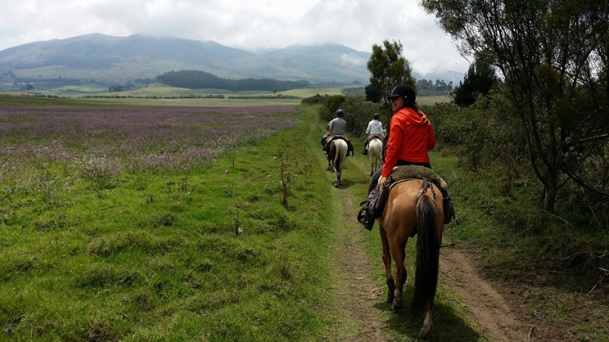
Rebecca Braak (24) grew up in a small town in the Netherlands where she was riding horses daily. At the age of 18 she moved to Amsterdam where she studied Business Administration at the University of Amsterdam and fairly quickly completed this study. "This was a great period of my life, full of wonderful friends. Immediately after my MBA graduation, I also worked in a wonderful position at my dream company KLM - Royal Dutch Airlines. But something very important was missing in my life; Horses! So I decided to go to Ecuador for three months, volunteering on a horse ranch in the Andes. I felt wonderful and happy at this beautiful Ecuador, so I have decided to move to Quito. And that decision has been one of the best decisions in my life! "
KLM flies daily from Amsterdam to Quito. Tickets at the ‘wereld deal weken’ from approximately USD 850 . More information about the tours of Rebecca Braak on: www.ecuahorserides.com

